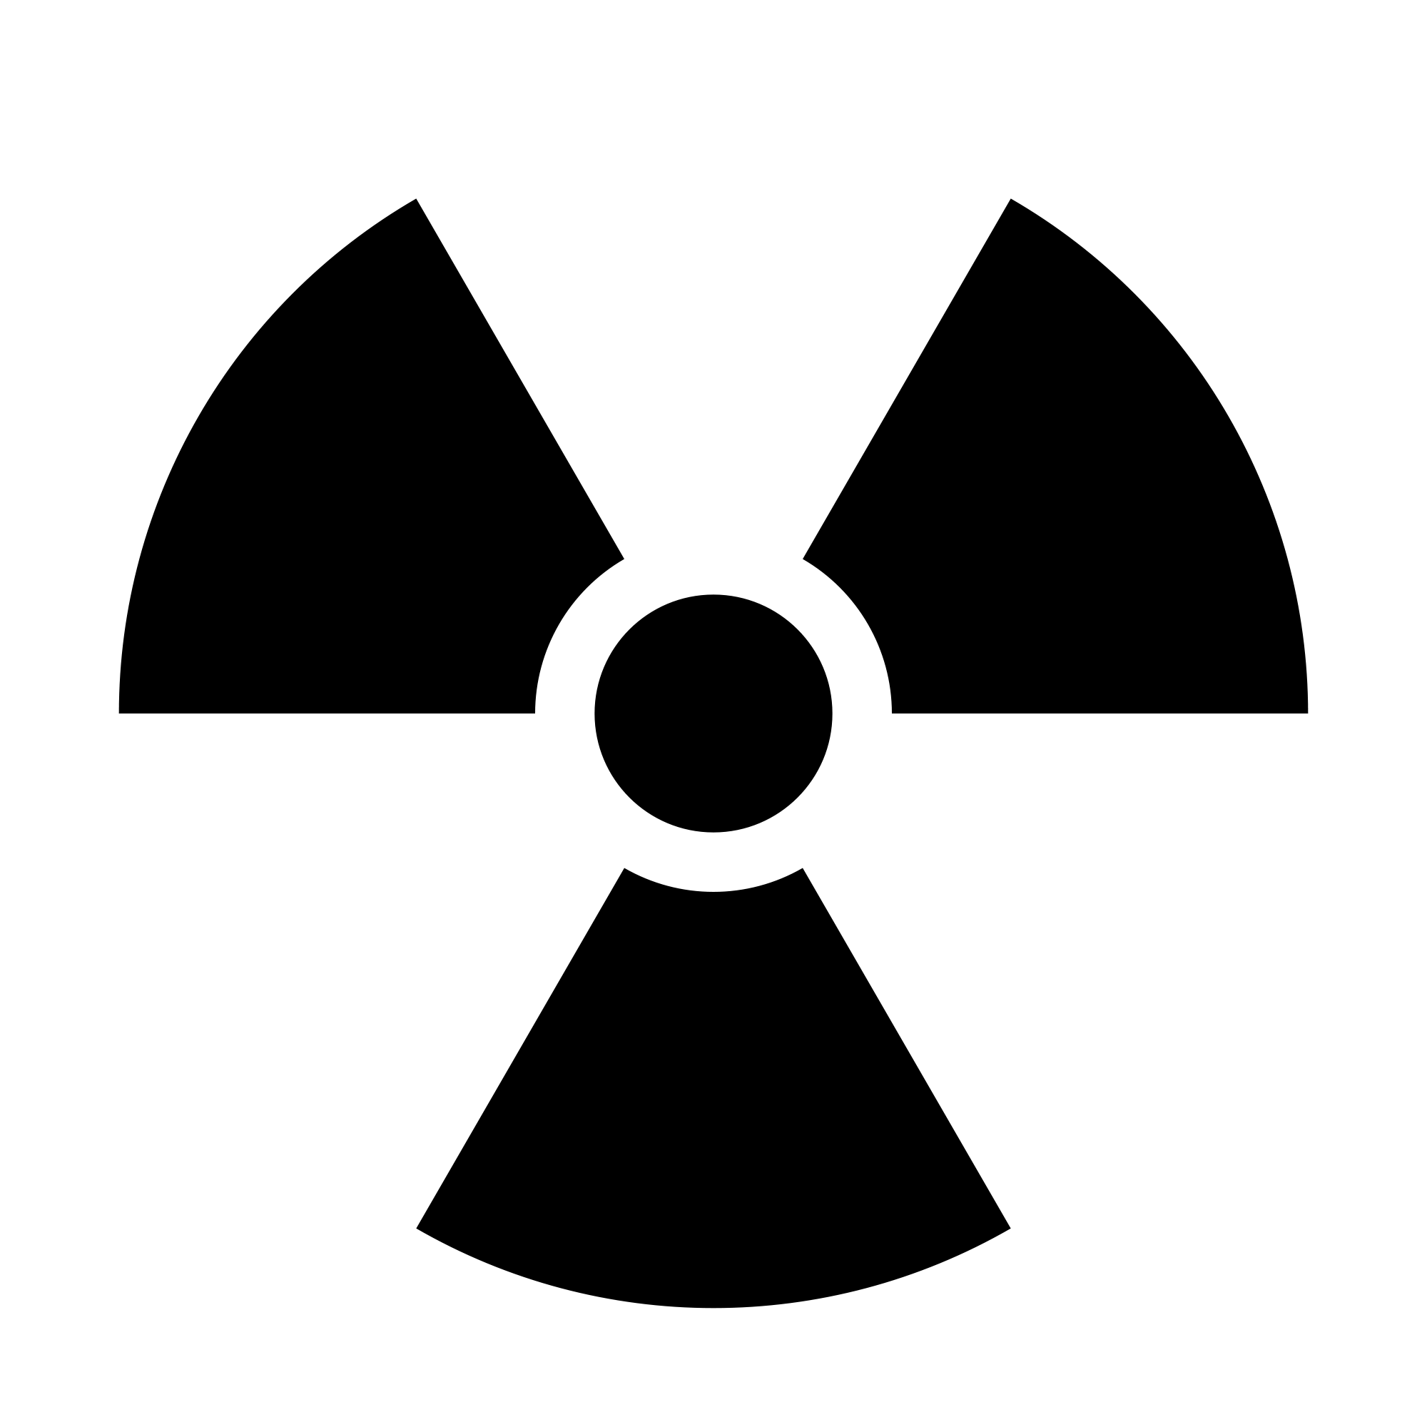**THE UNIVERSITY OF BRITISH COLUMBIA**

# Radiation Safety Committee

# TERMS OF REFERENCE

**Introduction**

The University of British Columbia holds licenses from the Canadian Nuclear Safety Commission for the use of radioactive sources. All use of radioactive sources by a university member under the auspices of the university is governed by the terms of these licenses. UBC Policy #11 on Radiation Safety is intended to ensure the safe and lawful procurement, use and disposal of radioactive sources for research at the university in compliance with the licences. It authorizes the UBC Advisory Committee on Radioisotopes and Radiation Hazards (Radiation Committee) to act as the agent for the University in all matters of control, review and mediation arising from the use or production of radioactive materials and ionizing radiation at the university.

**Membership**

1. The Vice-President Research will appoint the members of the Radiation Committee. Appointments will be for three years with the possibility of renewal.
2. Where practicable, one member of the Radiation Committee will also be a member of the TRIUMF Safety and Quality Assurance Oversight Panel.
3. As part of the oversight of the use of radioactive materials in human subjects, one member of the committee will be a nuclear medicine physician.
4. The Vice-President Research will appoint the Chair of the Radiation Committee for a three-year term with the possibility of renewal. The Vice-President Research will appoint an Associate Chair of the Radiation Committee, who may act as the chairperson in the absence of the Chair.
5. The Radiation Safety Officer (RSO) will be a non-voting member of the Radiation Committee.
6. The Vice-President Research may invite representatives of the British Columbia Ministry of Health-Radiation Branch and the Canadian Nuclear Safety Commission to be non-voting members of the Radiation Committee.
7. A quorum will comprise a minimum of five voting members of the Radiation Committee. Decisions will be made by majority vote and the Chair shall vote in decisions.

**Mandate**

Under the authority of the Vice-President, Research, the committee is authorized to:

1. Issue permits authorizing University faculty members to acquire and use radioactive sources provided that such use is in accordance with the term of the License;
2. Deny, suspend or terminate such permits;
3. Exercise control and oversight generally relating to the acquisition, use and disposal of radiation materials for research purposes.

**Duties and Responsibilities**

The responsibilities of the committee include:

1. Ensuring that all persons involved in the handling of radioisotopes have adequate training and experience enabling them to perform their duties safely and in accordance with the University’s radiation safety program and CNSC requirements;
2. Ensuring that equipment and facilities used with radiation sources are in compliance with CNSC requirements; and
3. Ensuring processes are in place such that doses of ionizing radiation received by any person using radioisotopes do not exceed the limits specified in the CNSC regulations.
4. Consult, communicate and/or cooperate with the responsible physician or body (such as Scientific or Ethical Review Committees) as necessary to assure the safe use of radioactive materials and compliance with licence conditions and regulations in research, diagnosis or therapy on human subjects.

As authorized by the University, the committee shall:

1. Oversee radiation safety on behalf of the University;
2. Advise the University and the RSO on radiation safety matters, including the safe use of radioactive materials during licensed activities;
3. Review all proposed or existing UBC Radiation Safety Programs and procedures to determine whether they assure that radiation exposures will comply with regulatory limits and will be as low as reasonably achievable, as described in CNSC regulations;
4. Review all proposed uses of radioisotopes, and their proposed locations of use, to determine whether these proposals comply with university procedures and regulatory requirements;
5. Assess the adequacy, in terms of the contents and schedules for delivery, of the institutions’ programs to train staff and workers in the safe use and handling of radioactive and possibly radioactive materials;
6. Review the results of internal inspections of facilities, premises, equipment, and work practices that assess whether radioisotopes are used safely in CNSC-licensed activities;
7. Review annual summaries of the occupational radiation exposures received by staff and workers to determine whether these exposures are as low as reasonably achievable;
8. Review reports concerning any incidents or unusual occurrences at the institution that involved radioactive materials;
9. Require corrective measures or improvements be implemented when review or assessment identifies deficiencies in a proposal, program, practice, procedure, equipment, record or report;
10. Require measures or improvements be implemented to prevent recurrences of any incidents that exposed staff or workers to excessive radiation, or to prevent recurrence of any other unusual occurrences involving radioactive materials;
11. Advise management of any perceived need for additional resources to establish, maintain or improve Radiation Safety Programs; and
12. Maintain written records of Committee activities, decisions, advice and recommendations concerning radiation safety, including details of meetings and reviews of data, reports, programs, procedures, circumstances, incidents or unusual occurrences.

**Committee Meetings**

The committee will schedule meetings twice each year to be held in the spring and fall months. Additional meetings may be called at the request of the Chair.

Minutes of all committee meetings, once approved by the committee and signed by the Chair are submitted to the Vice -President Research.

**Reviewing Terms of Reference**

The terms of reference of the Advisory Committee on Radiation and Radiation Hazards shall be periodically reviewed and amended by the University as may be required.

**Document Reviewed: November, 2007**

**Committee Members**

|  |  |
| --- | --- |
| Chair, Dr. Rosemary Redfield  Dept. of Zoology | Ph: 822-3744  redfield@interchange.ubc.ca |
| Dr. Carolyn Brown  Dept. of Medical Genetics | Ph: 822-0908  cbrown@ubc.ca |
| Dr. Roger Brownsey  Dept. of Biochemistry | Ph: 822-6560  rogerb@mail.ubc.ca |
| Associate Chair, Dr. Urs Hafeli  Faculty of Pharmaceutical Sciences | Ph: 822-7133  urs.hafeli@ubc.ca |
| Dr. Maite Maldonado  Dept. of Earth & Ocean Sciences | Ph: 822-4198  mmaldonado@eos.ubc.ca |
| Dr. Vince Duronio  Dept. of Experimental Medicine | Ph: 875-4707  vduronio@mail.ubc.ca |
| Dr. Vesna Sossi  Dept. of Physics and Astronomy | Ph: 822-7110  vesna@phas.ubc.ca |
| Dr. Dan Worsley  Nuclear Medicine | Ph: 875-6279  worsley@truimf.ca |
| Ex-Officio: Dr. John Hepburn  Acting Vice-President, Research | Ph: 822-4813  john.hepburn@ubc.ca |
| Ex-Officio: Dr. Anne Trudel  TRIUMF Safety and Quality Assurance Oversight Panel | Ph: 222-7372  atrudel@triumf.ca |
| Ex-Officio: Dr. Ted Sedgwick  Chemical & Radiation Safety Officer | Ph: 822-7052  ted.sedgwick@ubc.ca |
| Ex-Officio: Bruce Anderson  Risk Management Services | Ph: 822-7596  bruce.anderson@ubc.ca |
| Ex-Officia: Cherie Michels  Safety and Environment Advisor, UBC O | Ph: 250-807-8656  Cherie.michels@ubc.ca |

**TS November, 2014**

**N:\Documents\Committee\2007**