Safe Work Procedure Guidance Document

Overview

A standard operating procedure is a step-by-step guide that workers follow to ensure quality of final product. A safe work procedure, on the other hand, is a guide that incorporates all the information from the risk assessment in a manner that allows one to carry out the task safely. It is a detailed record of the step-by-step process of how to conduct a task. Before writing a safe work procedure, there must be a completed hazard identification and risk assessment. Once the procedure is written, individuals need to be trained on the procedure and that training needs to be documented.

General Procedure of Creating a Safe Work Procedure

These steps are to be completed by the supervisor:
- Conduct a “Risk Assessment” to identify the hazard(s) associated with each task and the associated pre control risk level
- Establish controls to minimize the risk and then identity the post control residual risk level
- Develop a “Safe Work Procedure (SWP)” to carry out the job. This procedure will incorporate findings from the “Risk Assessment” and identified controls.
- Submit the completed SWP for review to the Joint Occupational Health and Safety Committee (JOHSC). The SWP will undergo review as per Figure 1.
- Train all applicable workers on the approved “Safe Work Procedure” and document the training.
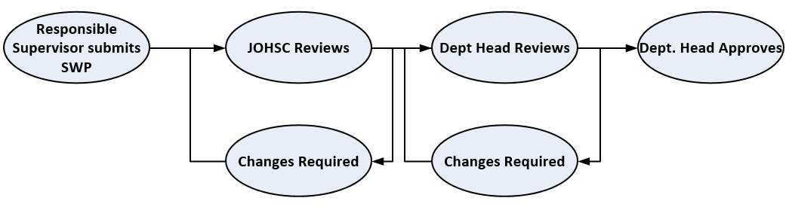
- Ensure documented training records are readily available to indicate that the worker has been trained in the task/procedure that will be carried out.
Figure 1: Safe Work Procedure Approval Process

Note: The risk assessment should be based on what is reasonably anticipated. If at any time, there is a change in location, timing, equipment, environment or any other factor that could affect the worker’s safety, a new hazard identification and risk assessment will be required and changes to the safe work procedure may be necessary.

Instructions for completing the Safe Work Procedure:

The UBC “Safe Work Procedure Template” is to be used alongside the UBC “Risk Assessment Template.”

Complete the sections in the “Safe Work Procedure Template” with the aid of the supporting documentation provided in the appendices of this document: “Safe Work Procedure Guidance Document.”

Appendix A: Regulations

Identify the relevant sections of the any or all of the following regulations as it pertains to the work. Some examples regulations and relevant sections are listed below.
- Workers Compensation Act
  - Section 115: General Duties of Employers, 116: General Duties of Workers, General Duties of Supervisors 117
- WorkSafeBC Occupational Health and Safety Regulation
- Transportation of Dangerous Goods Regulations
- Human Pathogens and Toxins Act
- Radiation Protection Regulations
- Nuclear Substances and Radiation Devices Regulations

Appendix B: Training Requirements

List any other training requirements as required by the task. See some examples below:

Additional Training Required
- Program Specific Training Courses (e.g. biological safety, radiation safety, chemical safety)
  - (http://rms.ubc.ca/training-and-general-education-courses/mandatory-training-for-all-ubc-workers/)

Appendix C: Materials/Equipment

List the specific materials and equipment that would be used to perform your tasks. Some categories of examples are listed below:
- Personal protective equipment
- Tools
- Equipment
- Chemicals
- Materials (wood, sheet metal, concrete, etc.)

Appendix D: Emergency Rescue and Evacuation Procedures

EMERGENCY PROCEDURES
Identify the emergencies that could reasonably occur during the field work. For each emergency, identify the steps that will be taken. The table below outlines some common hazards in different work environments but is not an inclusive list.

 | Hazards
Alpine/Sub-Alpine | Altitude Sickness | Sudden weather change in condition
Desert and Arid | Attack/Poisoned by Predator, Venomous snakes and insects | Heat Stroke | Heat Exhaustion
High Mountains and Polar Regions | Altitude Sickness | Hypothermia | Attack by Wild Animals
Tropical and Subtropical | Attack/Poisoned by Predator, Venomous snakes and insects | Flooding
Farmland | Aggressive large animal | Heat stroke | Hypothermia
Hills, Mountains, Cliffs | Sudden change in weather (fog, snow) | Hypothermia or Hyperthermia | Falls
Marine including Inshore, Coastal, Shorelines and Open Water | Drowning | Landslips | Quick sands and mudflats
 | Attack/Poisoned by Predator (Jellyfish) | Getting cut off by tidal changes or rapidly changing water levels
Moorland | Fire | Wild animals
Woodland and Forest | Fire | Wild animals

Some generic steps that can be included include as a part of your emergency procedures include:
- Seek first aid
- Contact supervisor
- Report incident in CAIRS
- Call for assistance
- Activate a locator beacon or high visibility equipment if present

Note: Detailed examples of procedures can be found in “Remote Off-Campus Emergency Procedures”

