X-RAY INSTRUMENT REGISTRATION FORM

STEP 1: LOCATION INFORMATION
Building Name

Room Number: (sub-rooms addressed separately)
Number of doors leading to the space
Is there existing signage indicating X-RAYS are present?
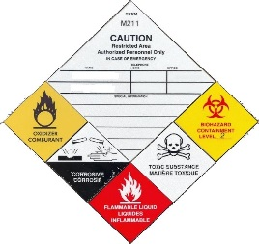

STEP 2: UNIT DESCRIPTION

Parameter | Description
Manufacturer
Model #
Serial #
Type (XRD, Dental, Crystallographic, etc)
Peak kilovoltage (kVp)
Max current (mA)
Use (Research, Teaching, etc)
Use Frequency (daily, weekly, monthly)

STEP 3: EMERGENCY CONTACT INFORMATION:

 | Principal Investigator | Responsible Individual
Name
Position
Office Phone Number
Emergency Phone Number
Email

STEP 4: SUBMISSION

Once completed, please send to researchsafety@rms.ubc.ca. All information collected will be kept secure and provided only to First Responders on a need to know basis. You may be contacted about establishing or updating your Laboratory Hazard Signage if the information you have provided differs from what we currently have recorded for your space.

