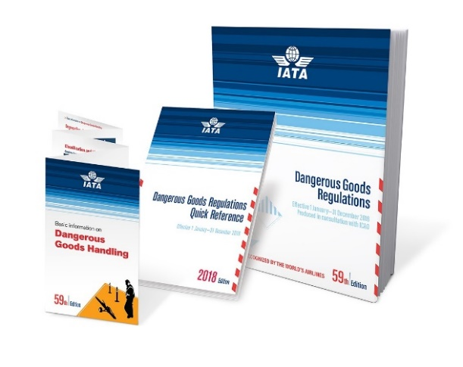
Shipment of Biological Substances to UBC
The shipment of biological substances considered to be infectious or potentially infectious are is globally regulated. All shipments sent to UBC must conform these standards, as outlined in the IATA Dangerous Goods Regulations.
These regulations provide instructions for:
- Training of people shipping dangerous goods
- Selection & use of certified packaging materials
- Application of hazard labels & other safety marks
- Documentation requirements
- Emergency response
- Reporting of incidents & accidents
The sections below will help to you to determine the requirements for your shipment.
Classification - Assessing the Consequences of Exposure
The requirements for packaging, labeling and documenting a biological substance shipment depend on the severity of the health risks associated with the material. Below is a decision tree published by Transport Canada to help determine the classification of your shipment.
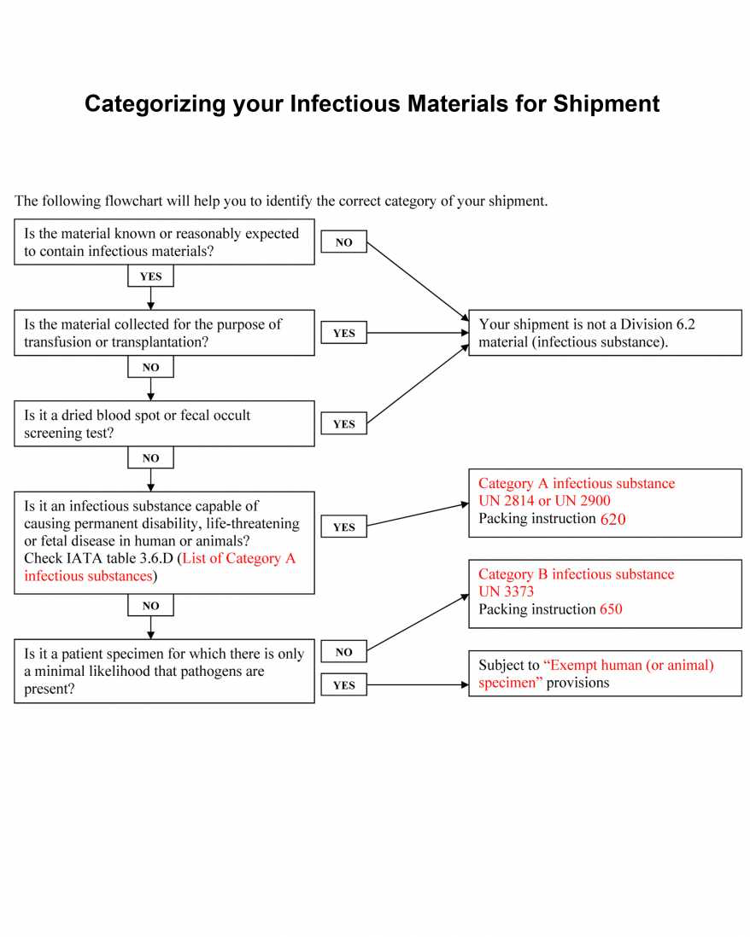
Category A Shipments: UN2814 & UN2900
Category A shipments carry the most risk to health and so have the most stringent packaging, labeling and documentation requirements. Type 1A packaging is required and only 50 mL of Category A material may be sent in a single shipment on a passenger & cargo aircraft. Larger volumes may be sent as ‘Cargo only’ or split up across multiple shipments. For air transport, a Shippers Declaration of Dangerous Goods is required. Please contact your courier service for assistance in completing this document.

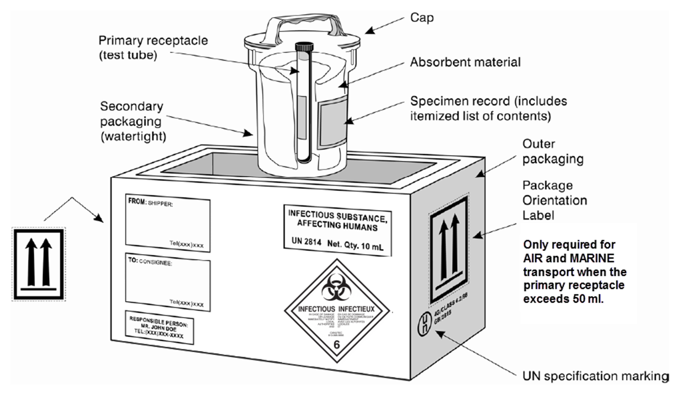

Category B Shipments: UN3373
Category B shipments have moderate packaging, labeling and documentation requirements. Triplicate packaging is still required to prevent any possibility of leakage, but a Shippers Declaration of Dangerous Goods is not required. Type 1B packaging is sufficient, though Type 1A is also acceptable. The UN3373 label and a 24hr contact number is also required.
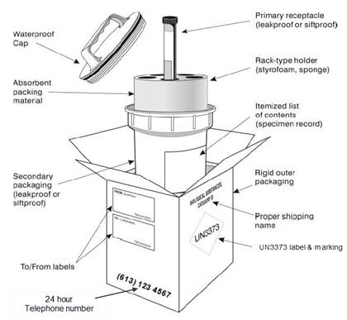

Exempt Shipments
Biological materials, collected directly from humans, animals or the environment or purified from biological systems in a laboratory that are being transported for research, diagnosis, investigational activities or prevention where you have no reason to believe that the specimen contains an infectious substance. Fixed or paraffin-embedded samples fall into this category. There are 4 types of Exempt Specimens:
  - Exempt Human Specimen (e.g. blood, saliva, sputum)
  - Exempt Animal Specimen (e.g. tissue, blood)
  - Exempt Biological Product (e.g. plasmid DNA, vaccines, protein samples)
  - Exempt Environmental Samples (e.g. water, soil)

Exempt specimens must still be packaged to prevent any chance of leakage during transport and must be labeled as ‘Exempt Specimens’.

