LABORATORY HAZARD SIGNAGE FORM

STEP 1: GENERAL INFORMATION
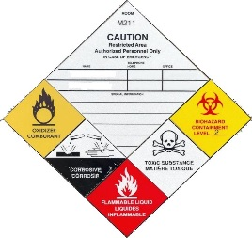
Building Name
Room Number: (sub-rooms addressed separately)
Number of doors leading to the space
Is there an existing sign? (as seen in picture on left)

STEP 2: HAZARDS PRESENT IN THE LAB

Hazard Class* | Pictogram | Description/Additional Information | Y/N
Biohazard | 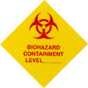 | Biohazard Symbol is required for Risk Group 2 and 3  Containment Level: _____ Biosafety Approval # ______________
Risk Group 1 |  | For working with Biohazards from Risk Group 1  Biosafety Approval # ______________
Compressed Gas Cylinders | 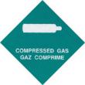 | Non-flammable, non-toxic gas placed under pressure and/or chilled, and contained by a cylinder
Corrosives | 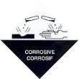 | Materials that cause severe and permanent burns to skin and tissue and can damage clothing, metals and/or other materials
Explosives | 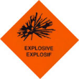 | Materials that cause a sudden release of gas, heat, and pressure when subjected to a certain amount of shock, pressure, or temperature
Flammable Gas |  | Gases that easily catch on fire at normal or elevated temperatures  Note: Gas taps do not qualify
Flammable Liquid | 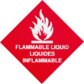 | Liquids that have a flash point below 37.8 °C
Flammable |  | Solids that can undergo combustion with or without a source of ignition  If both flammable liquids and solids are present, only use “Flammable”
Lasers | 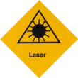 | Signage and registration required for Class 3B or 4. Please submit a registration form
Oxidizers | 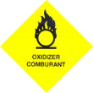 | React to promote or initiate the combustion of flammable or combustible materials
Radiation | 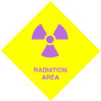 | Ionizing Radiation, that emits alpha, beta particles, positron emission, gamma rays, and x-rays  Isotope(s) used: _____________ Radiation Permit # ____________
Toxic Gas | 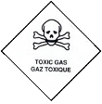 | Gases causing immediate toxic effects
Toxic Substances | 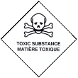 | Substances that cause immediate toxic effects
X-Rays | 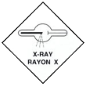 | X-ray system consisting of an x-ray source or generator. Please submit a registration form
*To help identify hazard class, use WHMIS pictograms on labels or Safety Data Sheets, or TDG pictograms on shipping containers

STEP 3: EMERGENCY CONTACT INFORMATION:

 | Principal Investigator | Responsible Individual
Name
Position
Office Phone #
Emergency Phone #
Email

To ensure that Emergency First Responders obtain the appropriate hazard and contact information, signs containing emergency contact information will be posted on the outer door(s) of the room. Please choose one of the following options:

☐ Option #1: The sign will display names, position titles, and phone numbers of the PI and the Responsible Individual.
☐ Option #2: The sign will display position titles and phone numbers (but not names) of the PI and the Responsible Individual.
☐ Option #3*: The sign will display the phone number for campus security. Information of the PI and the Responsible Individual will be stored by SRS in a secure database and only disclosed to campus security if required in an emergency.
*Please note that using this option may result in delays retrieving accurate, up-to-date information regarding hazards in the lab.

STEP 4: SPECIAL INFORMATION

Please indicate any additional information you would like added to the sign
(Example: “Required PPE: lab-coat, full-covering liquid resistant shoes, long loose fitting pants”)

STEP 5: ADDITIONAL PRINCIPAL INVESTIGATORS/RESPONSIBLE INDIVIDUALS (IF REQURIED)

Name: | Position:
Office Phone #: | Emergency Phone #:
Email:

Name: | Position:
Office Phone #: | Emergency Phone #:
Email:

Name: | Position:
Office Phone #: | Emergency Phone #:
Email:

Name: | Position:
Office Phone #: | Emergency Phone #:
Email:

STEP 6: RETURN FORM TO SMS (research.safety@ubc.ca)

